CHAPTER 8: Forces, energy and motion
Worksheet 8.1

Speed and velocity
Science Quest 10: pages 308–10
Answers

Calculating average speed
1. The average speed (v) for a journey is calculated using the formula:
v = | d
v = | t
where d = distance travelled and t = time taken.
Complete the following table. Make sure you include the appropriate units for each quantity.
Distance travelled | Time taken | Average speed
100 m | 20 s | 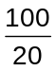 = 5 m/s
3 km | 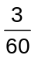 = 0.05 h | 60 km/h
20 × 15 = 300 m | 15 s | 20 m/s
2 km | 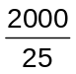 = 80 s | 25 m/s

Average speed and average velocity
2. Two vehicles (X and Y) travel from A to C along different paths as shown in the diagram (not drawn to scale). X travels along the path ABC and vehicle Y travels along AC. The triangle ABC is a right angle triangle. A is north of B.
 | 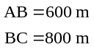 | 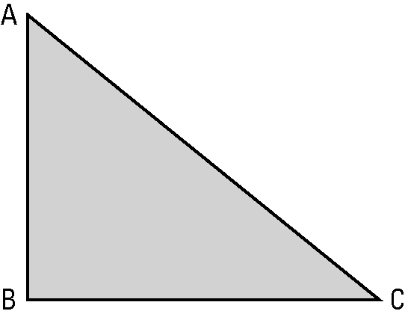 | 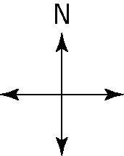
Both vehicles take 70 s for the trip.
Perform the necessary calculations to complete the table.
Average speed of X | Average velocity of X | Average speed of Y | Average velocity of Y
d = 800 + 600  = 1400 m  t = 70 s  v = 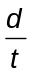 = 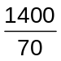  = 20 m/s | v = 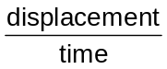  = 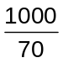  = 14.3 m/s  Direction = 37 °S of E  (draw a scale diagram  and measure the  angle) | d(AC) = 1000 m (this  is a 3:4:5 right  triangle)  t = 70 s  v = =  = 14.3 m/s | v =  =  = 14.3 m/s  Direction = 37 °S of E  (draw a scale diagram  and measure the  angle)

